Ansible Challenge

Create ci pipeline that will deploy and configure these VMs using terraform and ansible according following requirements
- Deploy 2 virtual machines using terraform.
  - first vm on Amazon linux, hostname: c8.local
  - second vm on ubuntu 21.04, hostname: u21.local
- As a result of terraform execution, dynamically create inventory for ansible
  - c8.local should be in the frontend group
  - u21.local should be in the backend group
- Create ansible playbook for c8.local and u21.local
- for linux OS playbook should apply the following changes
  - selinux: disable
  - firewalld: disable
- for frontend playbook group should install and configure nginx
  - nginx configuration should do proxying from port 80 on port 19999 to the
  - backend group
- for the backend group, the playbook must install the Netdata application from the
  - official repositories and run it on port 19999.

Challenge 1: Deploy 2 virtual machines using terraform.
  - first vm on Amazon linux, hostname: c8.local
  - second vm on ubuntu 21.04, hostname: u21.local

1. Objective
Deploy two virtual machines on AWS EC2 using Terraform:
- Frontend VM: Amazon Linux 2023, hostname c8.local.
- Backend VM: Ubuntu 24.04 LTS, hostname u21.local.
Terraform will provision the infrastructure automatically. In later steps, we’ll configure the VMs using Ansible and integrate the workflow with Jenkins.

2. Architecture
Jenkins Pipeline
Runs Terraform and Ansible
Terraform provisions resources
AWS — us-east-1 (North Virginia)
Frontend VM
Amazon Linux 2023
Hostname: c8.local
Backend VM
Ubuntu 24.04 LTS
Hostname: u21.local
Terraform manages EC2 instances, security groups, and the generated Ansible inventory. Ansible configuration comes after successful infrastructure verification.

3. Implementation plan
Step | Task | Expected result
1 | Verify prerequisites and AWS permissions | Ready to provision
2 | Create Terraform configuration | Infrastructure code prepared
3 | Run Terraform plan | Proposed changes reviewed
4 | Run Terraform apply | Two EC2 instances created
5 | Verify instance details and hostnames | Both VMs confirmed
6 | Generate Ansible inventory | Frontend and backend groups available
7 | Configure both VMs using Ansible | Required configurations applied
8 | Integrate with Jenkins | Automated workflow

4. Implementation — Step 1: Verify the working environment
We have already verified Java, Terraform, Ansible, Git, Python, AWS CLI, and Jenkins's SSH key. Now confirm the project directory and AWS region before creating Terraform files.
Run these commands on your Jenkins server:
cd ~/terraform-ansible-ci

echo "===== PROJECT DIRECTORY ====="
pwd
ls -la

echo "===== AWS IDENTITY ====="
aws sts get-caller-identity

echo "===== AWS REGION ====="
aws configure get region

echo "===== TERRAFORM VERSION ====="
terraform version

echo "===== AWS VPC CHECK ====="
aws ec2 describe-vpcs \
--region us-east-1 \
--query 'Vpcs[].VpcId' \
--output table
Expected verification:
- Project directory: /home/ubuntu/terraform-ansible-ci
- AWS identity succeeds using the Jenkins server's IAM role.
- AWS region is us-east-1, or we explicitly pass that region in Terraform.
- Terraform reports its installed version.
- AWS returns the available VPC IDs.
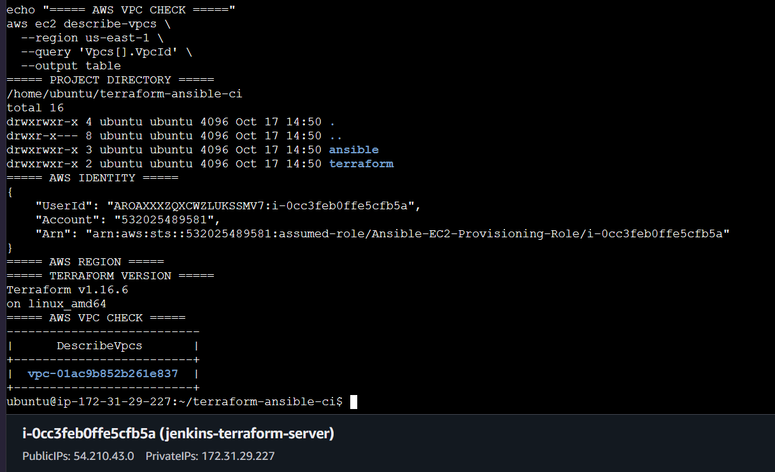

Step 2 — Create the Terraform configuration
We’ll create the configuration inside your existing terraform directory. This step prepares the code and reviews the planned changes; it does not launch VMs.

2.1 Create main.tf
Run these commands on your Jenkins server:
cd ~/terraform-ansible-ci/terraform

cat > main.tf <<'EOF'
terraform {
required_providers {
aws = {
source = "hashicorp/aws"
version = "~> 6.0"
}
}
}

provider "aws" {
region = "us-east-1"
}

# Existing Jenkins instance
data "aws_instance" "jenkins" {
instance_id = "i-0cc3feb0ffe5cfb5a"
}

# Shared security group for both lab VMs
resource "aws_security_group" "lab" {
name = "terraform-ansible-lab-sg"
description = "Allow SSH from the Jenkins security group"
vpc_id = "vpc-01ac9b852b261e837"

ingress {
description = "SSH from Jenkins"
from_port = 22
to_port = 22
protocol = "tcp"
security_groups = [
tolist(data.aws_instance.jenkins.vpc_security_group_ids)[0]
]
}

egress {
from_port = 0
to_port = 0
protocol = "-1"
cidr_blocks = ["0.0.0.0/0"]
}

tags = {
Name = "terraform-ansible-lab-sg"
Project = "terraform-ansible-ci"
}
}

# Frontend VM: Amazon Linux 2023
resource "aws_instance" "frontend" {
ami = "ami-0856027a77429315a"
instance_type = "t3.micro"
key_name = "terraform-ansible-lab-key"
subnet_id = "subnet-0f10dcb8905109022"
vpc_security_group_ids = [aws_security_group.lab.id]
associate_public_ip_address = true

user_data = <<-USERDATA
#!/bin/bash
hostnamectl set-hostname c8.local
echo "c8.local" > /etc/hostname
USERDATA

tags = {
Name = "c8.local"
Hostname = "c8.local"
Role = "frontend"
Project = "terraform-ansible-ci"
}
}

# Backend VM: Ubuntu 24.04 LTS
resource "aws_instance" "backend" {
ami = "ami-02a9cdd4e98bc3c78"
instance_type = "t3.micro"
key_name = "terraform-ansible-lab-key"
subnet_id = "subnet-0f10dcb8905109022"
vpc_security_group_ids = [aws_security_group.lab.id]
associate_public_ip_address = true

user_data = <<-USERDATA
#!/bin/bash
hostnamectl set-hostname u21.local
echo "u21.local" > /etc/hostname
USERDATA

tags = {
Name = "u21.local"
Hostname = "u21.local"
Role = "backend"
Project = "terraform-ansible-ci"
}
}
EOF

2.2 Create outputs.tf
This file displays the instance IP addresses after Terraform creates the VMs.
cat > outputs.tf <<'EOF'
output "frontend_instance_id" {
description = "Frontend EC2 instance ID"
value = aws_instance.frontend.id
}

output "frontend_public_ip" {
description = "Frontend public IP"
value = aws_instance.frontend.public_ip
}

output "frontend_private_ip" {
description = "Frontend private IP"
value = aws_instance.frontend.private_ip
}

output "backend_instance_id" {
description = "Backend EC2 instance ID"
value = aws_instance.backend.id
}

output "backend_public_ip" {
description = "Backend public IP"
value = aws_instance.backend.public_ip
}

output "backend_private_ip" {
description = "Backend private IP"
value = aws_instance.backend.private_ip
}
EOF

2.3 Initialize and validate Terraform
Run the following commands one at a time:
terraform init
Expected result: Terraform initializes the AWS provider successfully.
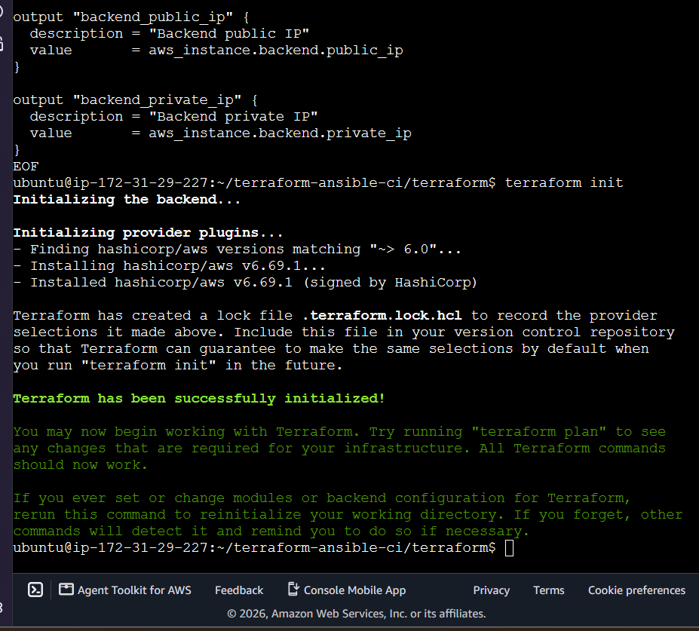
terraform fmt
Expected result: Terraform formats the configuration.
terraform validate
Expected result:
Success! The configuration is valid.
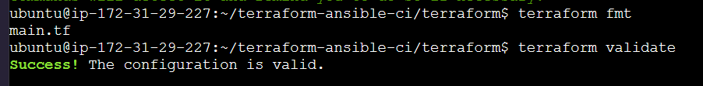

2.4 Review the plan — no VM creation yet
terraform plan
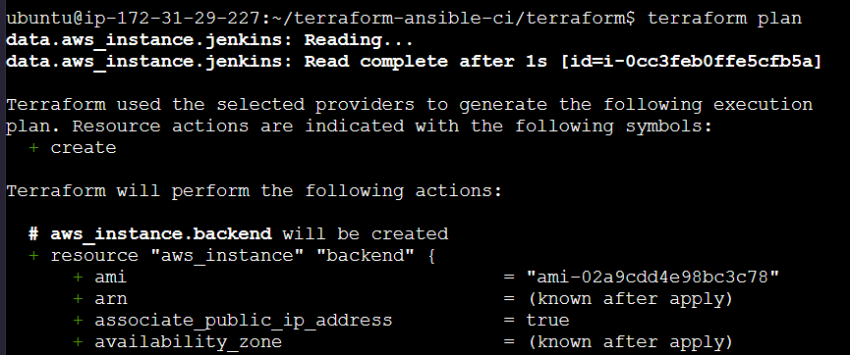
The plan should include these resources:
- 1 security group
- 2 EC2 instances
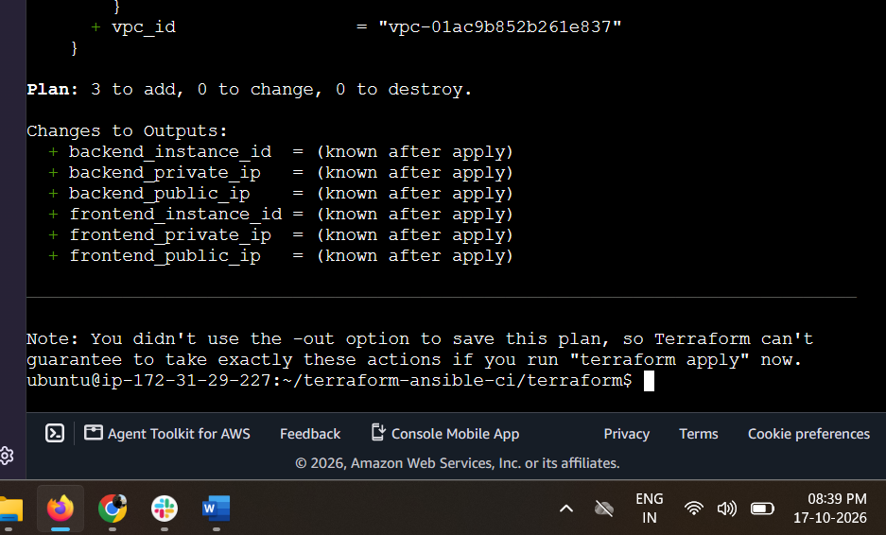

Expected outcome
At the end of this step, the Terraform configuration will be prepared and validated. The two VMs will not exist until we run terraform apply.

Step 3 — Create the two VMs
Before running terraform apply, verify that the two AMIs and the SSH key pair exist in us-east-1:
aws ec2 describe-images \
--region us-east-1 \
--image-ids ami-0856027a77429315a ami-02a9cdd4e98bc3c78 \
--query 'Images[*].[ImageId,Name,State]' \
--output table
aws ec2 describe-key-pairs \
--region us-east-1 \
--key-names terraform-ansible-lab-key \
--query 'KeyPairs[*].[KeyName,KeyPairId]' \
--output table
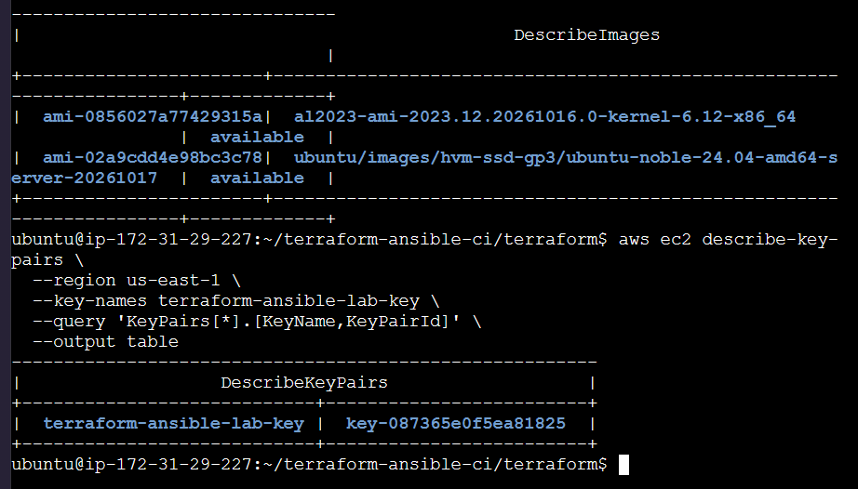
Both AMIs should be available, and the key pair should be returned.
If both checks pass, create the infrastructure:
cd ~/terraform-ansible-ci/terraform
terraform apply
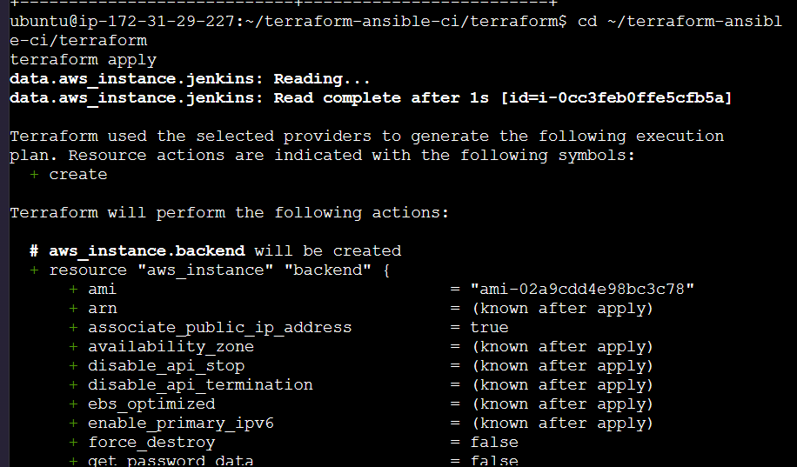
Terraform will display the proposed changes and ask for confirmation. Enter yes only after confirming the plan still says 3 to add, 0 to change, 0 to destroy.
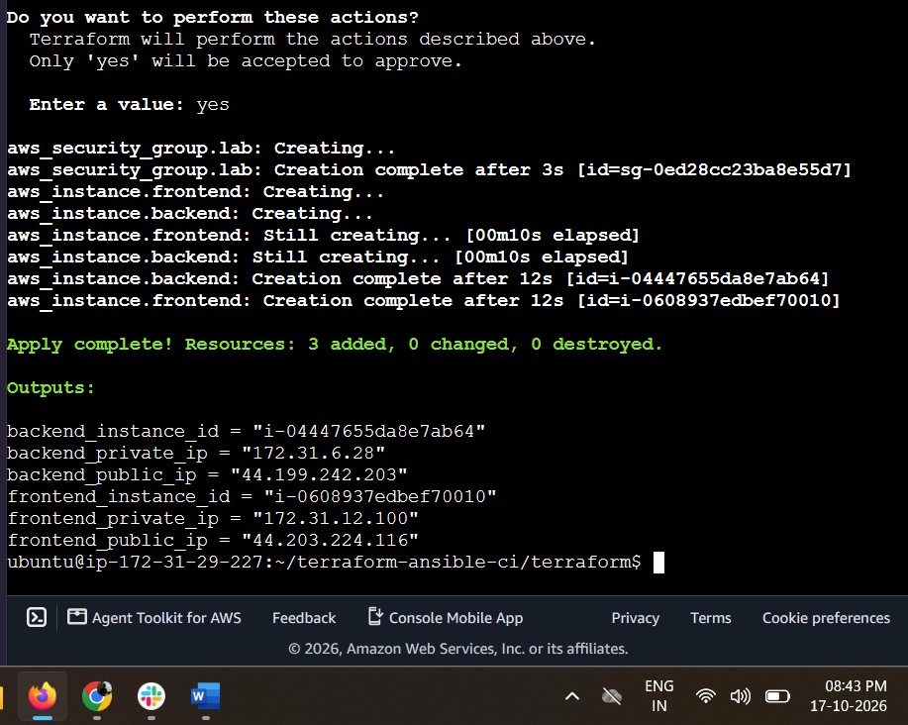
Expected outcome: Terraform creates the security group and both EC2 instances. Share the apply output after it completes; then we’ll verify the instance IDs, IP addresses, and hostnames before moving to the next step.

Step 4 — Verify both EC2 instances
Objective: Confirm that AWS reports both instances as running before we configure them.
Run this command from your Jenkins server:
aws ec2 describe-instances \
--region us-east-1 \
--instance-ids i-0608937edbef70010 i-04447655da8e7ab64 \
--query 'Reservations[].Instances[].{Name:Tags[?Key==`Name`]|[0].Value,InstanceId:InstanceId,State:State.Name,PrivateIP:PrivateIpAddress,PublicIP:PublicIpAddress,AMI:ImageId}' \
--output table

Expected outcome
Both instances should show running, with the correct IP addresses and AMI IDs.
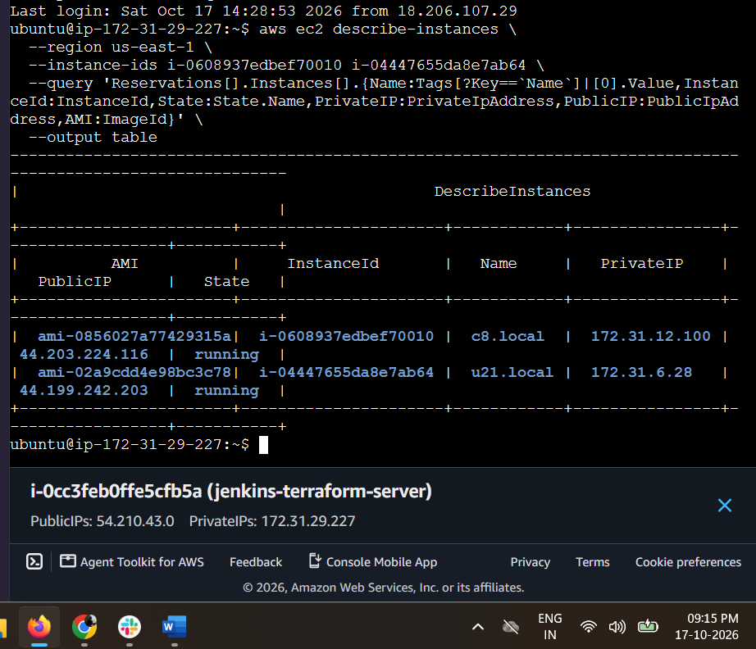

Step 5 — Verify SSH connectivity and hostnames
Next, we’ll verify that Jenkins can connect to both machines and that cloud-init has applied the requested hostnames.

5.1 Connect to the frontend
Run this from the Jenkins server:
sudo -u jenkins ssh \
-i /var/lib/jenkins/.ssh/terraform-ansible-lab-key.pem \
-o StrictHostKeyChecking=accept-new \
ec2-user@44.203.224.116 \
'hostnamectl --static; cat /etc/os-release | head -5'
Expected hostname:
c8.local
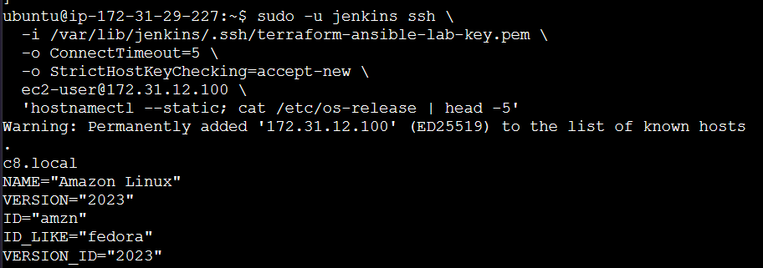

5.2 Connect to the backend
sudo -u jenkins ssh \
-i /var/lib/jenkins/.ssh/terraform-ansible-lab-key.pem \
-o StrictHostKeyChecking=accept-new \
ubuntu@44.199.242.203 \
'hostnamectl --static; cat /etc/os-release | head -5'
Expected hostname:
u21.local
The backend OS information should identify Ubuntu 24.04 LTS.
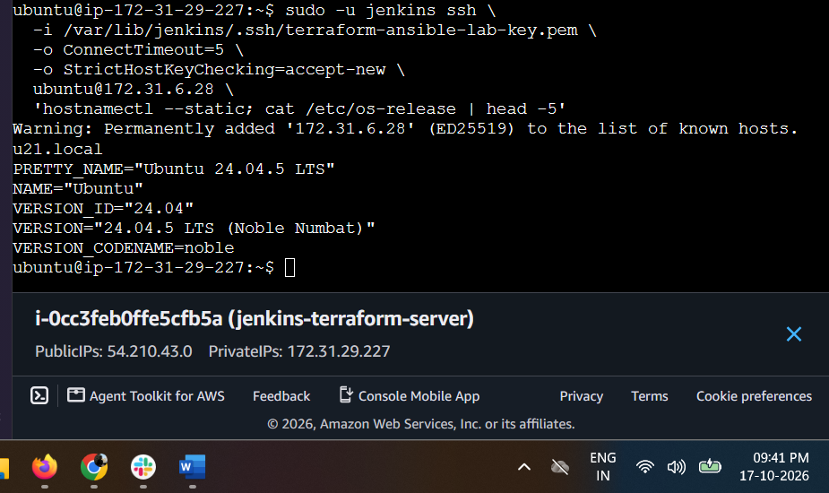

Step 7 — Generate the Ansible inventory using Terraform
Objective: Allow Ansible to identify the frontend and backend automatically using their private IP addresses.
We’ll use Terraform's local_file resource to generate inventory.ini. This inventory will be created on the Jenkins server.

7.1 Create the inventory template
On the Jenkins server, run:
cd ~/terraform-ansible-ci/terraform
Create inventory.tftpl:
cat > inventory.tftpl <<'EOF'
[frontend]
frontend ansible_host=${frontend_private_ip} ansible_user=ec2-user

[backend]
backend ansible_host=${backend_private_ip} ansible_user=ubuntu

[all:vars]
ansible_ssh_private_key_file=/var/lib/jenkins/.ssh/terraform-ansible-lab-key.pem
ansible_ssh_common_args='-o StrictHostKeyChecking=accept-new'
EOF

7.2 Add the inventory provider
Create inventory.tf:
cat > inventory.tf <<'EOF'
resource "local_file" "ansible_inventory" {
filename = "${path.module}/../ansible/inventory.ini"

content = templatefile("${path.module}/inventory.tftpl", {
frontend_private_ip = aws_instance.frontend.private_ip
backend_private_ip = aws_instance.backend.private_ip
})

file_permission = "0644"
}
EOF

7.3 Add the local provider
Open main.tf:
nano main.tf
Inside the existing terraform block, add the local provider alongside the AWS provider:
local = {
source = "hashicorp/local"
version = "~> 2.0"
}
Save and exit: Ctrl+O, Enter, then Ctrl+X.

7.4 Initialize and validate
Run:
terraform fmt
terraform init
terraform validate
Expected result:
Success! The configuration is valid.
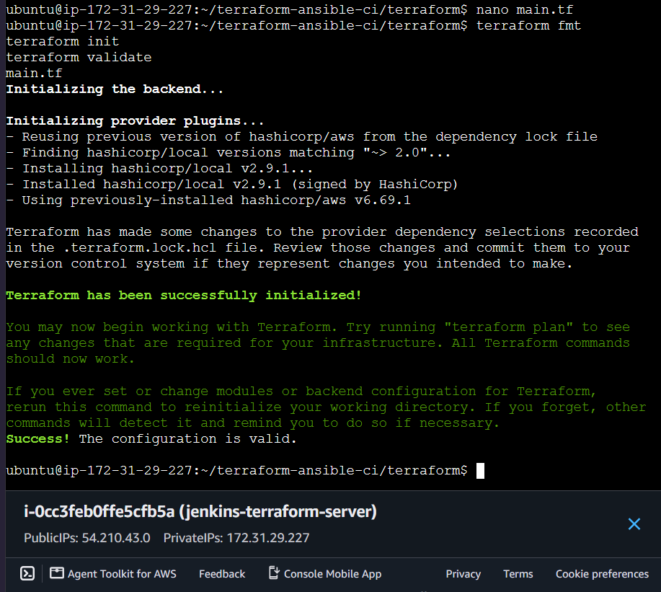
Then preview the change:
terraform plan
The plan should show the inventory file being created in addition to any Terraform state refreshes. It should not propose replacing or destroying either EC2 instance. If it proposes replacing an instance, stop and share the plan.

7.5 Apply the inventory change
If the plan is safe, run:
terraform apply
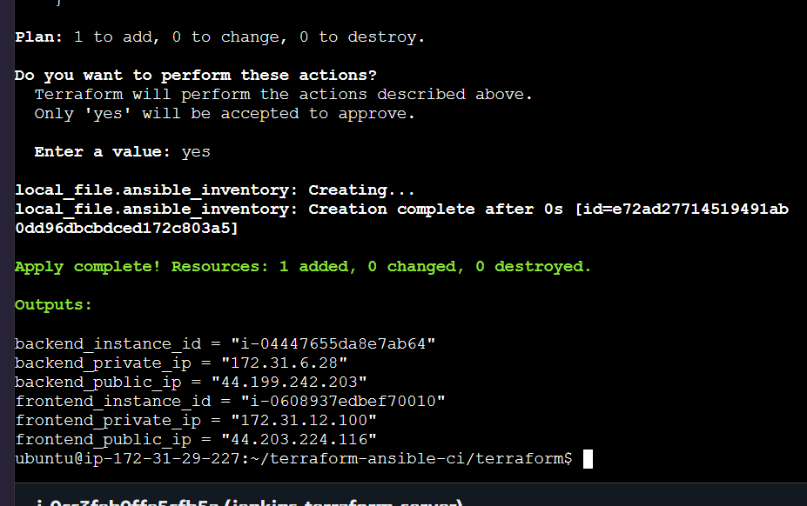
Confirm only after reviewing the plan. Then verify the generated inventory:
cat ../ansible/inventory.ini
Expected contents:
[frontend]
frontend ansible_host=172.31.12.100 ansible_user=ec2-user

[backend]
backend ansible_host=172.31.6.28 ansible_user=ubuntu

[all:vars]
ansible_ssh_private_key_file=/var/lib/jenkins/.ssh/terraform-ansible-lab-key.pem
ansible_ssh_common_args='-o StrictHostKeyChecking=accept-new'
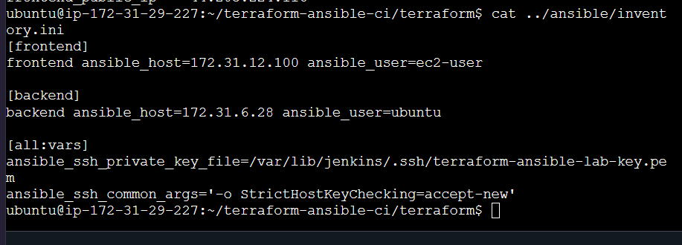
Expected outcome: Terraform generates an Ansible inventory containing both VM private IPs, without recreating the VMs.

Step 8 — Verify Ansible connectivity
Objective: Confirm that Ansible can connect to both VMs using the generated inventory.
Run these commands on the Jenkins server:

8.1 Check the frontend
cd ~/terraform-ansible-ci/ansible

sudo -u jenkins ansible frontend \
-i inventory.ini \
-m ping
Expected result:
frontend | SUCCESS => {
"changed": false,
"ping": "pong"
}
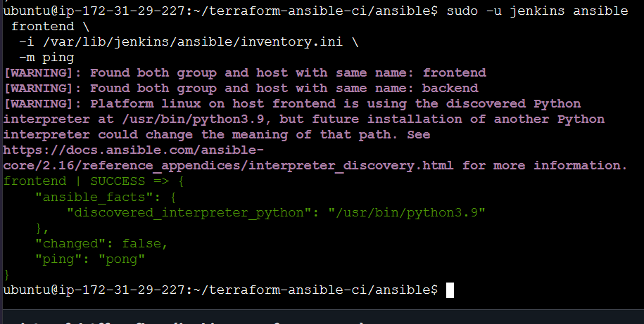

8.2 Check the backend
sudo -u jenkins ansible backend \
-i inventory.ini \
-m ping
Expected result:
backend | SUCCESS => {
"changed": false,
"ping": "pong"
}
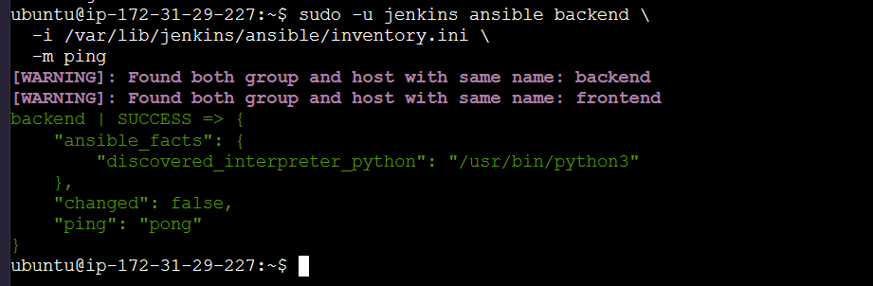

8.3 Check both VMs together
Only after the individual checks succeed, run:
sudo -u jenkins ansible all \
-i inventory.ini \
-m ping
Expected outcome: Both hosts return SUCCESS with "ping": "pong".
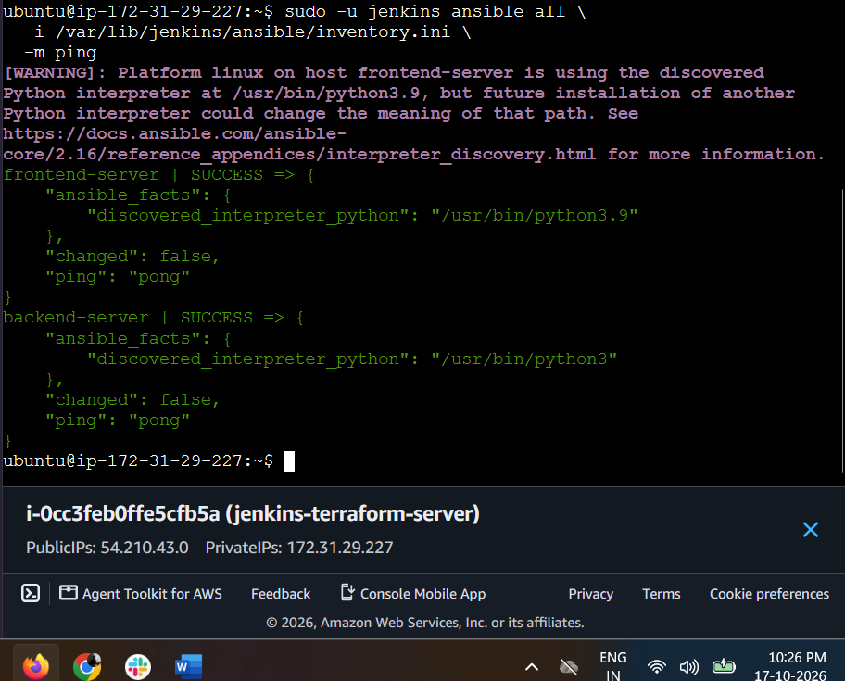

Step 9 — Create the frontend Ansible playbook
Objective: Configure the Amazon Linux 2023 frontend server to install and start Apache HTTP Server.

9.1 Create the playbook
Run on your Jenkins server:
cd ~/terraform-ansible-ci/ansible

nano frontend.yml
Paste this complete playbook:

---
- name: Configure frontend web server
hosts: frontend
become: true

tasks:
- name: Install Apache HTTP Server
ansible.builtin.dnf:
name: httpd
state: present

- name: Create frontend web page
ansible.builtin.copy:
dest: /var/www/html/index.html
content: |
<html>
<head><title>Terraform Ansible CI Challenge</title></head>
<body>
<h1>Frontend Server</h1>
<p>Deployed using Terraform and Ansible.</p>
</body>
</html>
owner: root
group: root
mode: "0644"

- name: Enable and start Apache
ansible.builtin.service:
name: httpd
state: started
enabled: true
Save using Ctrl+O, press Enter, then Ctrl+X.

9.2 Check the playbook syntax
Your inventory groups are still named frontend and backend, so use the inventory file under Jenkins's directory:
sudo -u jenkins ansible-playbook \
-i /var/lib/jenkins/ansible/inventory.ini \
--syntax-check \
~/terraform-ansible-ci/ansible/frontend.yml
Expected output:
playbook: /home/ubuntu/terraform-ansible-ci/ansible/frontend.yml
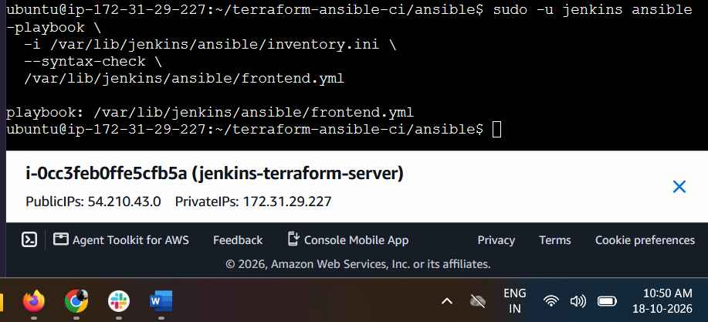
The hosts: frontend entry targets the frontend group, and become: true allows Ansible to install Apache with elevated privileges.

Step 9.3 — Run the frontend playbook
Run this command on Jenkins:
sudo -u jenkins ansible-playbook \
-i /var/lib/jenkins/ansible/inventory.ini \
/var/lib/jenkins/ansible/frontend.yml

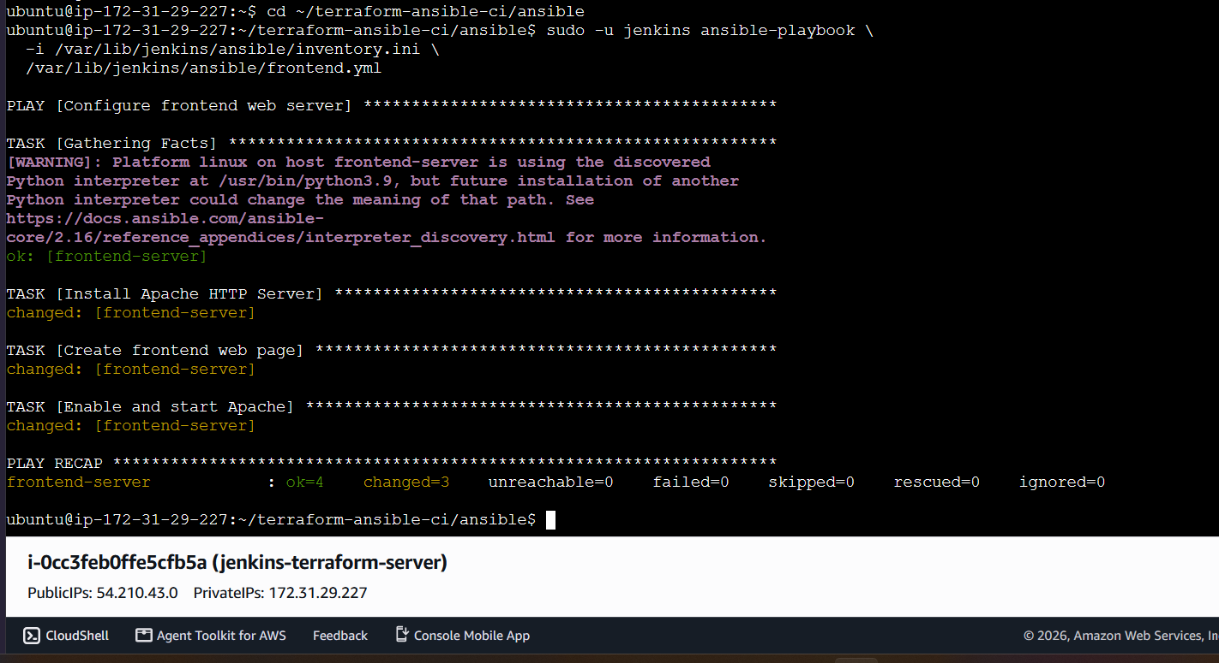
The playbook should:
- Install Apache (httpd) on Amazon Linux 2023.
- Create /var/www/html/index.html.
- Start Apache and enable it at boot.
Expected recap:
PLAY RECAP
frontend-server : ok=3 changed=3 unreachable=0 failed=0
The exact ok and changed counts may differ.

Step 9.4 — Verify Apache is running
Run this command from Jenkins:
sudo -u jenkins ansible frontend \
-i /var/lib/jenkins/ansible/inventory.ini \
-m command \
-a "systemctl is-active httpd"
Expected output:
frontend-server | CHANGED | rc=0 >>
active
Then verify the web page content:
sudo -u jenkins ansible frontend \
-i /var/lib/jenkins/ansible/inventory.ini \
-m command \
-a "curl -s http://localhost/"
You should see the HTML containing Frontend Server and Deployed using Terraform and Ansible.
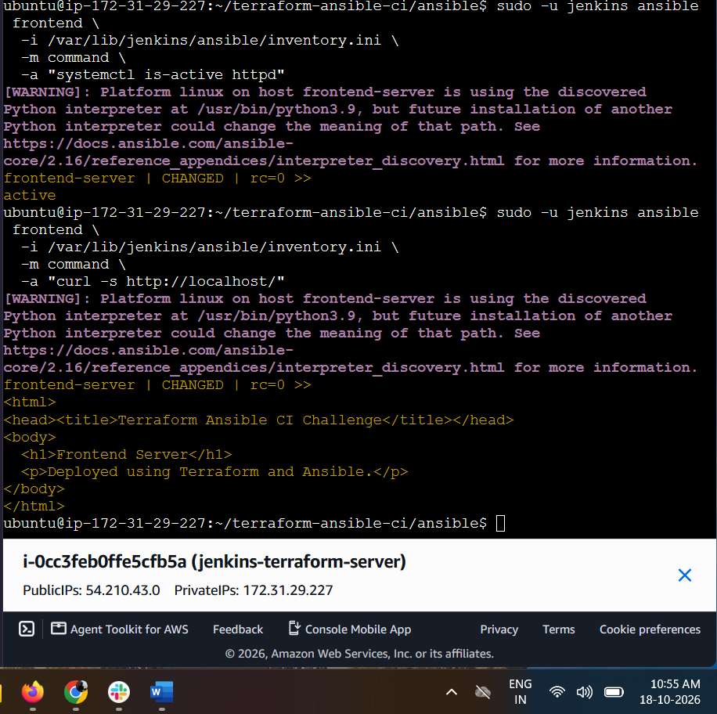

Step 10 — Create the backend Netdata playbook
The backend must run Netdata on port 19999. The intended traffic flow is:
Client / Browser
Frontend — Nginx
Port 80 → reverse proxy
Backend — Netdata
Port 19999

10.1 Create backend.yml
On your Jenkins server, run:
cd ~/terraform-ansible-ci/ansible
nano backend.yml
Paste this complete playbook:

---
- name: Install and configure Netdata on backend
hosts: backend
become: true

tasks:
- name: Install required packages
ansible.builtin.apt:
name:
- curl
- ca-certificates
state: present
update_cache: true
when: ansible_os_family == "Debian"

- name: Download official Netdata installer
ansible.builtin.get_url:
url: https://get.netdata.cloud/kickstart.sh
dest: /tmp/netdata-kickstart.sh
mode: "0755"

- name: Install Netdata using official supported packages
ansible.builtin.command:
cmd: sh /tmp/netdata-kickstart.sh --native-only --stable-channel
creates: /usr/sbin/netdata

- name: Enable and start Netdata
ansible.builtin.service:
name: netdata
state: started
enabled: true
Save with Ctrl+O, press Enter, then Ctrl+X.

10.2 Copy it to Jenkins's accessible Ansible directory
sudo install -o jenkins -g jenkins -m 644 \
~/terraform-ansible-ci/ansible/backend.yml \
/var/lib/jenkins/ansible/backend.yml

10.3 Check syntax only
sudo -u jenkins ansible-playbook \
-i /var/lib/jenkins/ansible/inventory.ini \
--syntax-check \
/var/lib/jenkins/ansible/backend.yml
Expected output:
playbook: /var/lib/jenkins/ansible/backend.yml
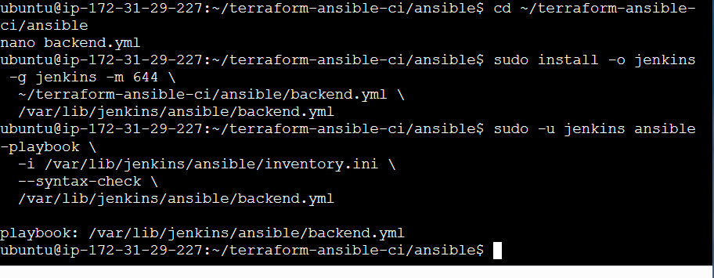

Step 10.3 — Install Netdata on the backend
Run this command on your Jenkins server:
sudo -u jenkins ansible-playbook \
-i /var/lib/jenkins/ansible/inventory.ini \
/var/lib/jenkins/ansible/backend.yml
This playbook will:
- Install required packages.
- Download the official Netdata installer.
- Install Netdata using its native package method.
- Enable and start the Netdata service.
The installation may take a few minutes.
Expected result: The play finishes with failed=0 and unreachable=0 for backend-server.
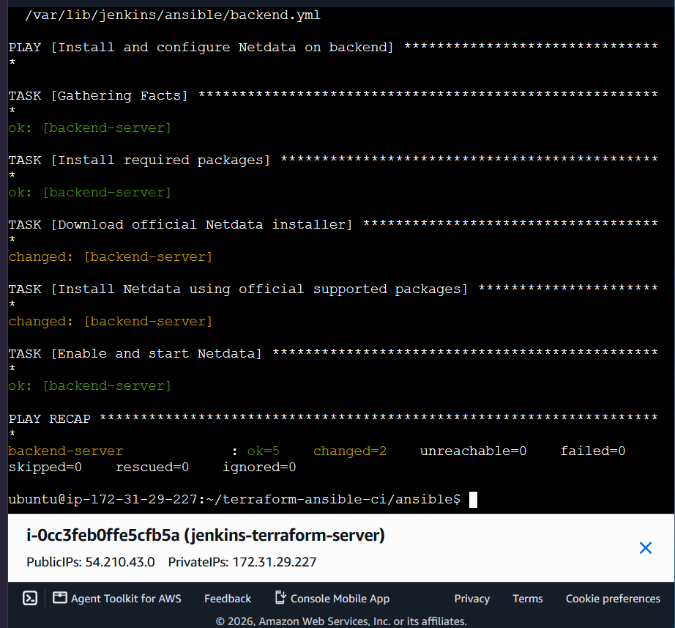

Step 10.4 — Verify Netdata
Run these commands on Jenkins:
1. Check the Netdata service
sudo -u jenkins ansible backend \
-i /var/lib/jenkins/ansible/inventory.ini \
-m command \
-a "systemctl is-active netdata"
Expected output: active
2. Check the listening port
sudo -u jenkins ansible backend \
-i /var/lib/jenkins/ansible/inventory.ini \
-m shell \
-a "sudo ss -lntp | grep ':19999'"
3. Test Netdata locally on the backend
sudo -u jenkins ansible backend \
-i /var/lib/jenkins/ansible/inventory.ini \
-m uri \
-a "url=http://localhost:19999/api/v1/info status_code=200"
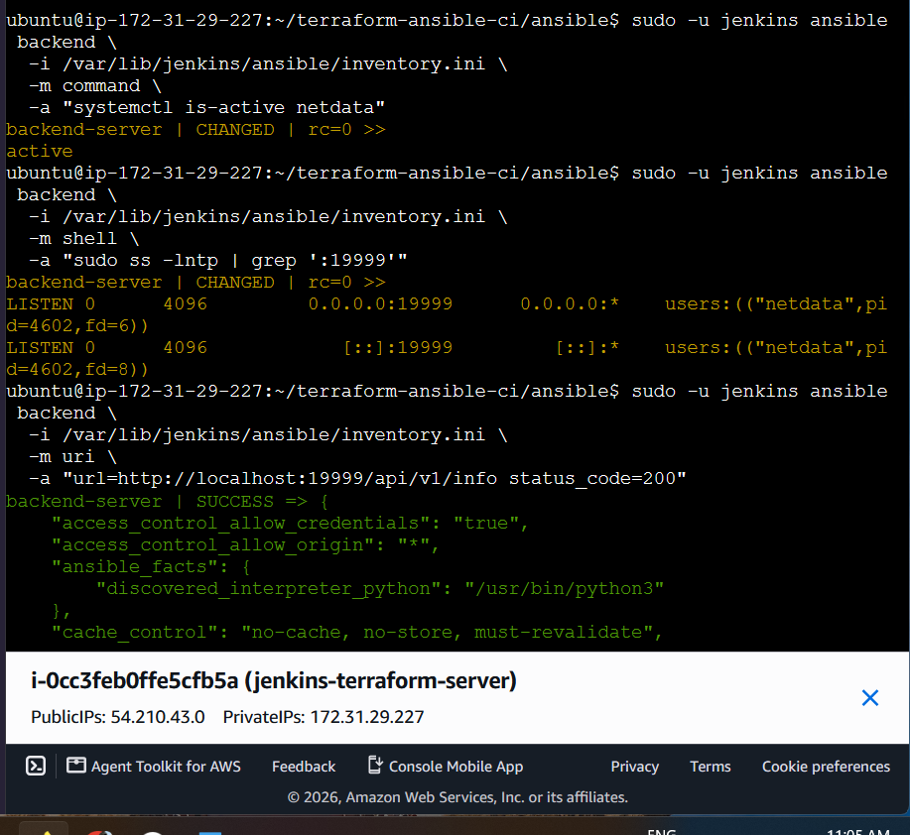

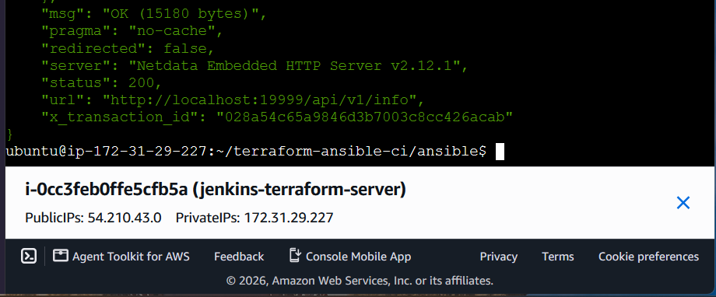
The third command should return HTTP status 200 if Netdata's API is responding.

Step 11 — Configure Nginx on the frontend
Objective: Replace Apache with Nginx and configure it to proxy requests to the backend Netdata service.
Our intended flow is:
Browser
|
| HTTP port 80
v
Frontend: c8.local
Nginx
|
| Proxy to backend:19999
v
Backend: u21.local
Netdata port 19999

11.1 Create frontend.yml
On Jenkins, run:
cd ~/terraform-ansible-ci/ansible
nano frontend.yml
Replace the existing contents with this complete playbook:

---
- name: Configure frontend Nginx reverse proxy
hosts: frontend
become: true

tasks:
- name: Remove Apache to avoid conflicting web servers
ansible.builtin.dnf:
name: httpd
state: absent

- name: Install Nginx
ansible.builtin.dnf:
name: nginx
state: present

- name: Configure Nginx reverse proxy to Netdata
ansible.builtin.copy:
dest: /etc/nginx/conf.d/netdata-proxy.conf
owner: root
group: root
mode: "0644"
content: |
server {
listen 80;
server_name c8.local;

location / {
proxy_pass http://172.31.6.28:19999;
proxy_http_version 1.1;
proxy_set_header Host $host;
proxy_set_header X-Real-IP $remote_addr;
proxy_set_header X-Forwarded-For $proxy_add_x_forwarded_for;
proxy_set_header X-Forwarded-Proto $scheme;
}
}
notify: Restart Nginx

- name: Enable and start Nginx
ansible.builtin.service:
name: nginx
state: started
enabled: true

handlers:
- name: Restart Nginx
ansible.builtin.service:
name: nginx
state: restarted
Save with Ctrl+O, press Enter, then Ctrl+X.
Note: This config uses your backend's current private IP, 172.31.6.28. We should make it dynamic using Ansible inventory variables before the final CI pipeline, so it remains correct if Terraform replaces an instance.

11.2 Copy the updated playbook to Jenkins's accessible directory
sudo install -o jenkins -g jenkins -m 644 \
~/terraform-ansible-ci/ansible/frontend.yml \
/var/lib/jenkins/ansible/frontend.yml

11.3 Check syntax
sudo -u jenkins ansible-playbook \
-i /var/lib/jenkins/ansible/inventory.ini \
--syntax-check \
/var/lib/jenkins/ansible/frontend.yml
Expected:
playbook: /var/lib/jenkins/ansible/frontend.yml

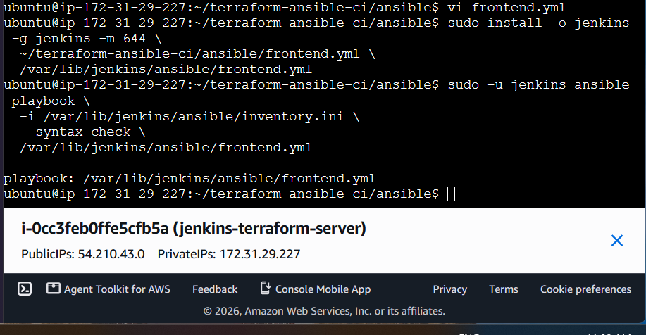

Step 11.2 — Execute the Nginx playbook
Run this command on Jenkins:
sudo -u jenkins ansible-playbook \
-i /var/lib/jenkins/ansible/inventory.ini \
/var/lib/jenkins/ansible/frontend.yml
This will:
- Remove Apache (httpd) to avoid a port 80 conflict.
- Install Nginx.
- Configure Nginx to proxy requests to backend Netdata at 172.31.6.28:19999.
- Enable and start Nginx.
Expected result: failed=0 and unreachable=0 for frontend-server.
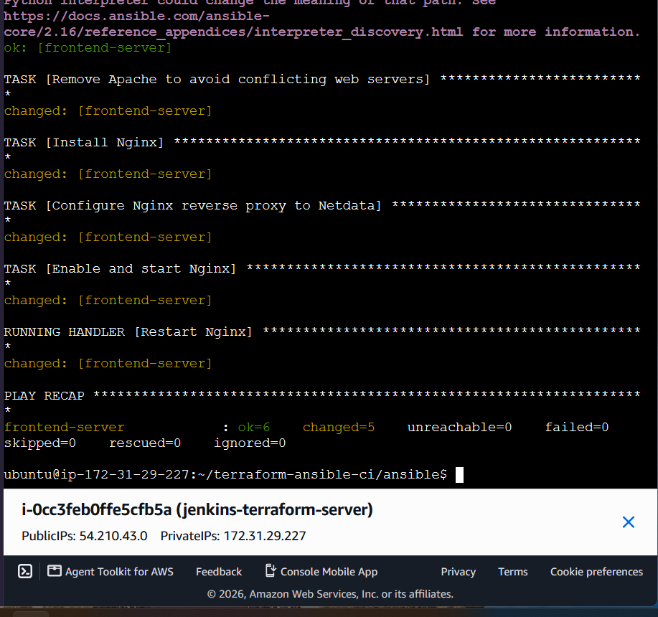

Step 11.3 — Verify the reverse proxy
Let's test the frontend and confirm that it returns the Netdata response.
1. Check Nginx is active
sudo -u jenkins ansible frontend \
-i /var/lib/jenkins/ansible/inventory.ini \
-m command \
-a "systemctl is-active nginx"
Expected: active
2. Check Nginx configuration syntax
sudo -u jenkins ansible frontend \
-i /var/lib/jenkins/ansible/inventory.ini \
-m command \
-a "nginx -t"
Expected: syntax is ok and test is successful.
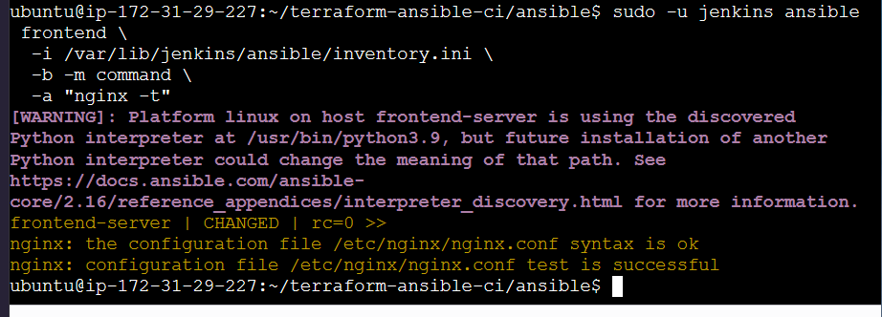
3. Test the proxy from the frontend itself
sudo -u jenkins ansible frontend \
-i /var/lib/jenkins/ansible/inventory.ini \
-m uri \
-a "url=http://localhost/ status_code=200 return_content=false"
Expected: HTTP status 200.
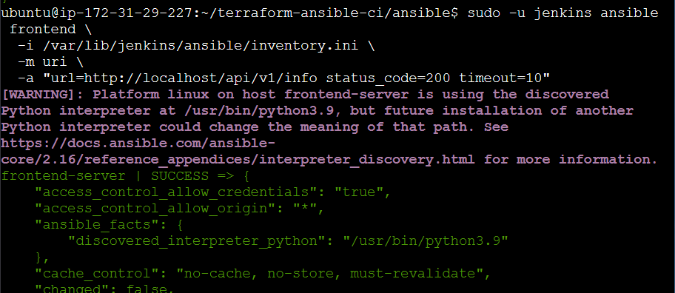
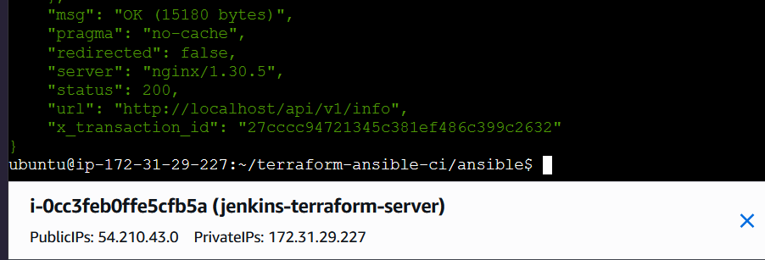

Next step: Step 12 — Create the Jenkins CI pipeline
The goal is to automate the work you have completed manually.
- Create a Jenkinsfile in your project directory.
- Add pipeline stages to:
  - Validate Terraform configuration.
  - Run terraform plan and apply approved changes.
  - Synchronize the Terraform-generated Ansible inventory.
  - Run backend.yml to configure Netdata.
  - Run frontend.yml to configure Nginx.
  - Verify the reverse proxy returns HTTP 200.

Step 12.1 — Create the Jenkinsfile
We will create the pipeline file in your existing project directory without changing your Terraform or Ansible files.
Run:
cd /home/ubuntu/terraform-ansible-ci
nano Jenkinsfile
Keep the file open. Don't paste any code yet.
First, run this command in another terminal or after exiting Nano:
sudo -u jenkins test -r /home/ubuntu/terraform-ansible-ci/terraform/terraform.tfstate \
&& echo "Terraform state: readable" \
|| echo "Terraform state: NOT readable"
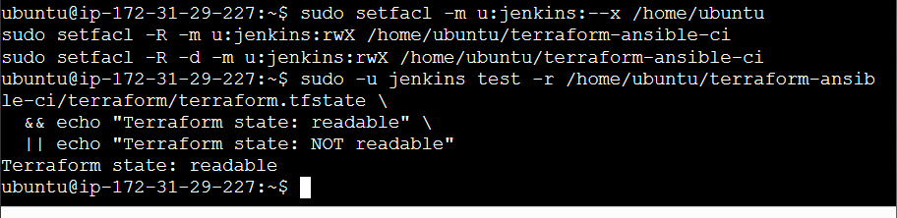
Step 12.2 — Create the Jenkins pipeline.

1. Create the Jenkinsfile
Run:
cd /home/ubuntu/terraform-ansible-ci
nano Jenkinsfile
Paste this complete pipeline:
pipeline {
agent any
options {
timestamps()
disableConcurrentBuilds()
}

environment {
TF_DIR = '/home/ubuntu/terraform-ansible-ci/terraform'
ANSIBLE_DIR = '/home/ubuntu/terraform-ansible-ci/ansible'
AWS_DEFAULT_REGION = 'us-east-1'
}

stages {
stage('Checkout / Validate Files') {
steps {
sh '''
set -eu
test -f "$TF_DIR/main.tf"
test -f "$TF_DIR/terraform.tfstate"
test -f "$ANSIBLE_DIR/inventory.ini"
test -f "$ANSIBLE_DIR/backend.yml"
test -f "$ANSIBLE_DIR/frontend.yml"

terraform version
ansible --version
aws sts get-caller-identity
'''
}
}

stage('Terraform Init') {
steps {
dir('/home/ubuntu/terraform-ansible-ci/terraform') {
sh 'terraform init -input=false'
}
}
}

stage('Terraform Validate') {
steps {
dir('/home/ubuntu/terraform-ansible-ci/terraform') {
sh 'terraform validate'
}
}
}

stage('Terraform Plan') {
steps {
dir('/home/ubuntu/terraform-ansible-ci/terraform') {
sh 'terraform plan -input=false -lock-timeout=60s -out=tfplan'
}
}
}

stage('Verify Ansible Connectivity') {
steps {
sh '''
ansible all \
-i "$ANSIBLE_DIR/inventory.ini" \
-m ping
'''
}
}

stage('Configure Backend - Netdata') {
steps {
sh '''
ansible-playbook \
-i "$ANSIBLE_DIR/inventory.ini" \
"$ANSIBLE_DIR/backend.yml"
'''
}
}

stage('Configure Frontend - Nginx') {
steps {
sh '''
ansible-playbook \
-i "$ANSIBLE_DIR/inventory.ini" \
"$ANSIBLE_DIR/frontend.yml"
'''
}
}

stage('Verify Reverse Proxy') {
steps {
sh '''
ansible frontend \
-i "$ANSIBLE_DIR/inventory.ini" \
-m uri \
-a "url=http://localhost/api/v1/info status_code=200 timeout=10"
'''
}
}
}

post {
success {
echo 'Pipeline completed successfully.'
}
failure {
echo 'Pipeline failed. Review the first failed stage in the console output.'
}
always {
echo 'Pipeline execution finished.'
}
}
}
Save in Nano using Ctrl+O, press Enter, then Ctrl+X.

2. Verify the Jenkinsfile was saved
Run:
cd /home/ubuntu/terraform-ansible-ci
sudo -u jenkins test -r Jenkinsfile \
&& echo "Jenkinsfile: readable" \
|| echo "Jenkinsfile: NOT readable"
Expected output:
Jenkinsfile: readable
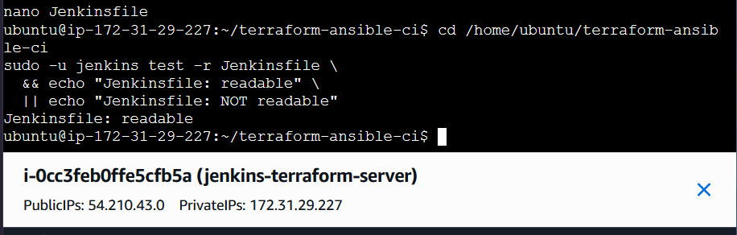

Step 12.3 — Create the Jenkins Pipeline job
Open Jenkins in your browser:
http://<Jenkins-public-IP>:8081
Use your Jenkins server's public IP address.
1. Create a new job
- Click New Item.
- Enter the name terraform-ansible-ci.
- Select Pipeline.
- Click OK.
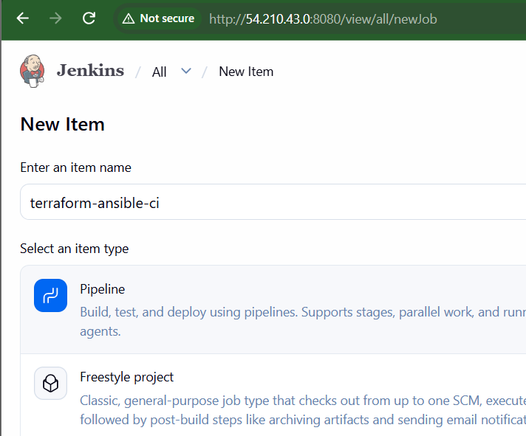
2. Configure the pipeline
- Scroll to the Pipeline section.
- For Definition, select Pipeline script from SCM only if your Jenkinsfile is in a Git repository. Otherwise, select Pipeline script.
- Since your Jenkinsfile currently exists locally, select Pipeline script for now.
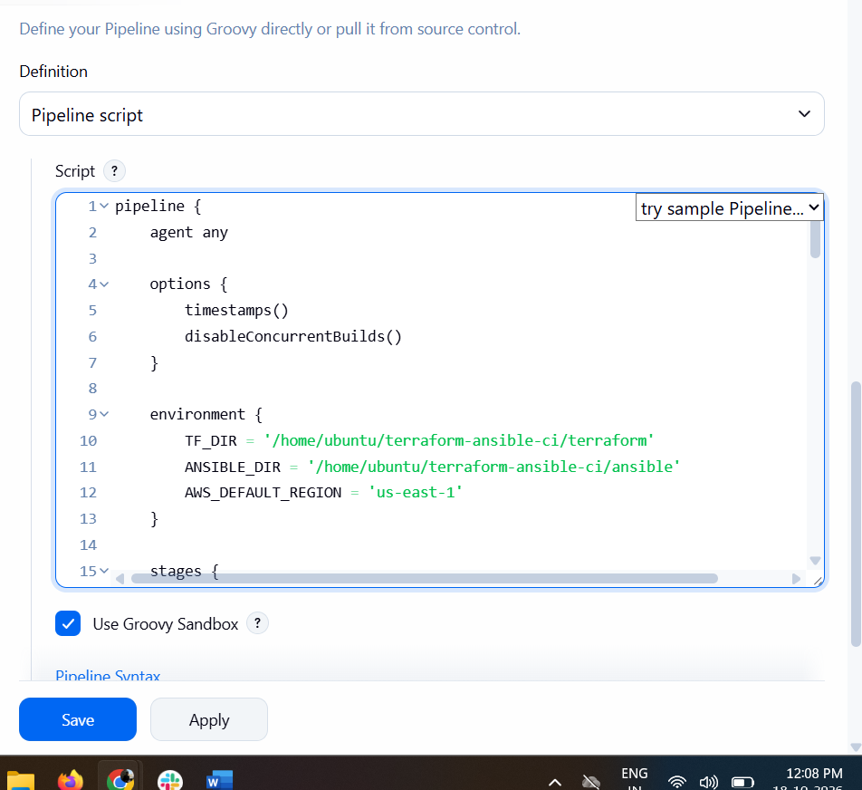

3. Save the job
The Jenkins UI script box does not automatically read /home/ubuntu/terraform-ansible-ci/Jenkinsfile.
We should load your saved Jenkinsfile into the job instead of maintaining two separate copies.

Step 12.4 — Run the first Jenkins build
- Open the terraform-ansible-ci job in Jenkins.
- Click Build Now.
- Under Build History, click the new build number (for example, #1).
- Click Console Output.
Wait for the build to finish. Check the status:
- Success (blue/green) — all pipeline stages passed.
- Failure (red) — at least one stage failed.
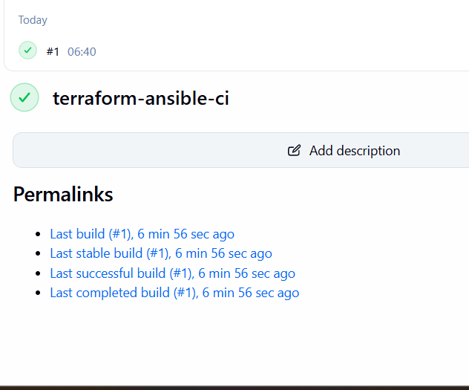
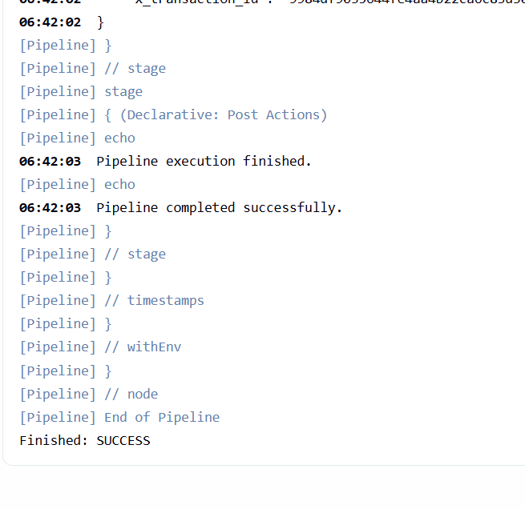
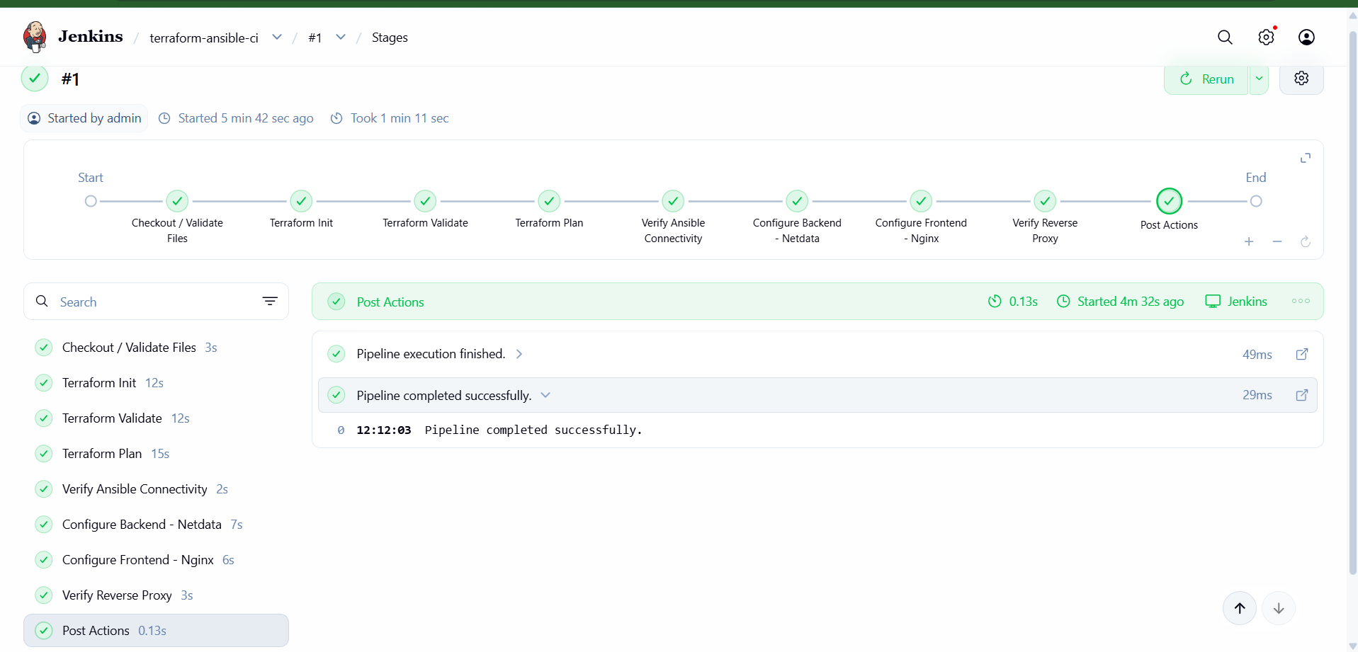

Next step: Let's verify the OS settings requirement before declaring the assignment complete.

Step 1: Check the current OS settings
Run this command on your Jenkins server:
cd /home/ubuntu/terraform-ansible-ci

sudo -u jenkins ansible all \
-i ansible/inventory.ini \
-m setup \
-a 'filter=ansible_os_family'
This checks the operating-system family of both servers.
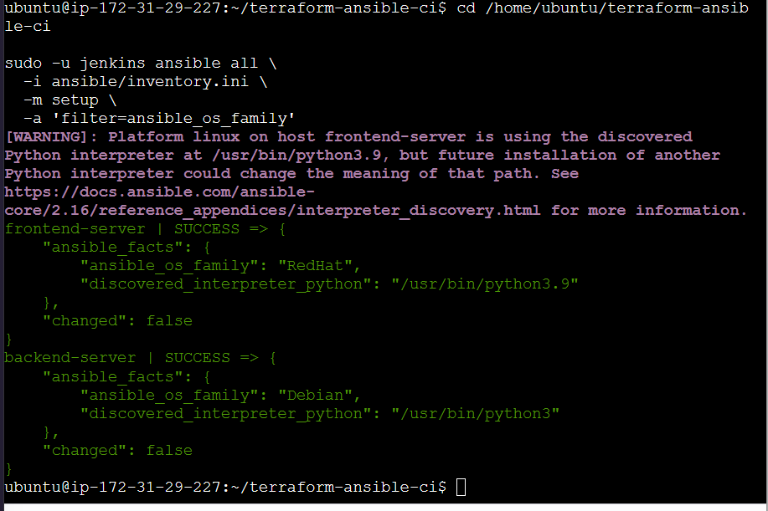

Step 2: Add OS settings to the Ansible playbooks
We'll disable SELinux on the Amazon Linux frontend and configure the firewall tasks appropriately for each OS. First, let's check the current SELinux status before changing anything.
Run:
sudo -u jenkins ansible frontend \
-i ansible/inventory.ini \
-m command \
-a 'getenforce'

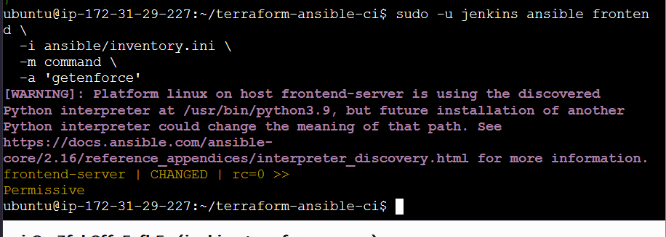

Next step: Final verification
Run this single command on your Jenkins server to verify that both VMs are reachable and the Netdata reverse proxy is responding:
cd /home/ubuntu/terraform-ansible-ci

sudo -u jenkins ansible all \
-i ansible/inventory.ini \
-m ping

sudo -u jenkins ansible frontend \
-i ansible/inventory.ini \
-m uri \
-a "url=http://localhost/api/v1/info status_code=200"
Expected result:
- Both VMs return SUCCESS and pong.
- The reverse-proxy check returns HTTP status 200.
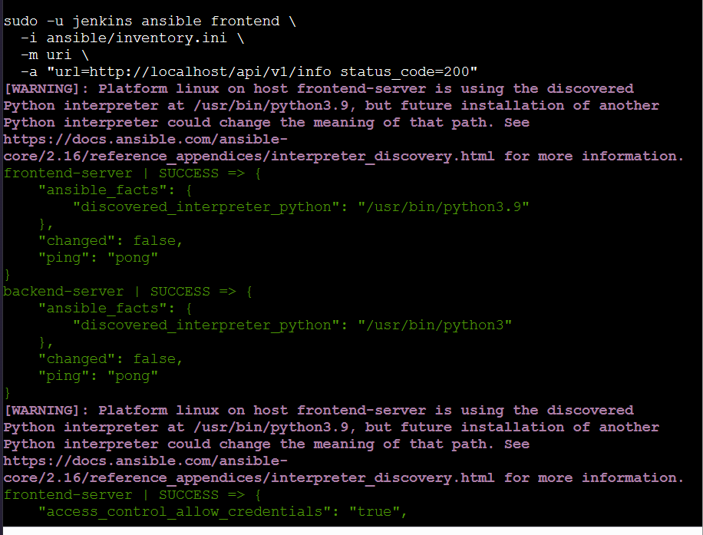
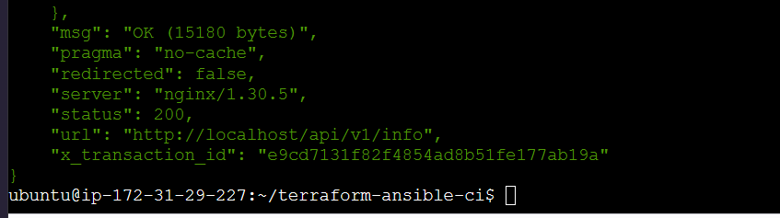

Overall Outcome of the Terraform + Ansible + Jenkins Challenge
Challenge status: Successfully completed, with one OS-version difference to note.
You successfully built an automated infrastructure configuration workflow using Terraform, Ansible, and Jenkins on AWS.

1. Final architecture
Jenkins CI Pipeline
Orchestrates Terraform and Ansible

Terraform
Validates infrastructure, plans changes, and generates dynamic Ansible inventory

Ansible
Connects to both EC2 instances and configures services

Frontend
c8.local

Nginx
Port 80
Reverse proxy
Backend
u21.local

Netdata
Port 19999
Monitoring dashboard and API
Jenkins build: SUCCESS
End-to-end pipeline verification passed

2. Challenge requirements and results
Requirement | Outcome
Provision/manage two AWS EC2 instances through Terraform | Existing instances managed through Terraform
Configure frontend hostname c8.local | Verified
Configure backend hostname u21.local | Verified
Generate Ansible inventory dynamically using Terraform | Completed
Separate frontend and backend groups in inventory | Completed
Configure Linux OS settings | SELinux persistently configured as disabled on frontend
Disable firewalld | Both hosts checked; firewalld is not installed
Install Nginx on frontend | Verified
Configure Nginx reverse proxy | Verified working previously
Install Netdata on backend | Verified
Enable Netdata at boot | enabled
Verify Netdata service | active
Verify Netdata API | HTTP 200
Execute automation through Jenkins | Build successful

3. How the request flows
Client / Browser
HTTP request to frontend port 80
Nginx — c8.local
Receives the request and forwards it
Netdata — u21.local:19999
Returns monitoring data through the proxy
The backend API was verified directly with an HTTP 200 response, and the reverse proxy was verified earlier. The successful Jenkins pipeline confirms the automated workflow completed.

4. What you learned
- Terraform: Infrastructure as code, resource state, planning changes, and dynamic inventory generation.
- Ansible: Inventory groups, SSH connectivity, privilege escalation, idempotent tasks, and service configuration.
- Jenkins: Pipeline stages, automation orchestration, execution logs, and build verification.
- Linux administration: SELinux configuration, service management, Nginx, and Netdata.
- AWS networking: Private IP communication and security-group-based access.

